**Life Cycle Plan (LCP)**

**Frenzy**

**Team 01**

|  |
| --- |
| **Team Members** |
| Arpan Badeka |
| Ankur Palav |
| Ashwin Hariharan |
| Rishabh Sharma |
| Jheel Somaiya |
| Sailee Rane |
| Alan Kwan |

**12/5/16**

**Version History**

**Date Author Version Changes made Rationale**

10/10/16 Jheel

1.0 Added Introduction and diagrams Initial draft for the LCP package.

Somaiya

10/17/16 Jheel

1.1 Added Future milestones, Coincomo FCR LCP package.

Somaiya

12/5/16 Jheel

Somaiya

1.2 Changed Incorrect Phase Dates Modified Development Phase Artifacts Added member responsibilities in

Development Phase

Added Estimation Conclusion and

Priorities in Iteration Plan

Final LCP Package

LCP_TRR_F16a_T01_V1.2 i Version Date: 12/5/16

**Table of Contents**

**Life Cycle Plan (LCP)**

**Version History ........................................................................................................................................................... ii Table of Contents ........................................................................................................................................................iv Table of Tables.......................................................................................................................................................... vii Table of Figures ..........................................................................................................................................................i1**

**1. Introduction ................................................................................................................................................2**

**1.1 Purpose of the LCP ....................................................................................................................................2**

**1.2 Status of the LCP .......................................................................................................................................2**

**1.3 Assumptions................................................................................................................................................2**

**2. Milestones and Products ............................................................................................................................3**

**2.1 Overall Strategy .........................................................................................................................................3**

**2.2 Project Deliverables ...................................................................................................................................4**

**3. Responsibilities ...........................................................................................................................................7**

**3.1 Project-specific stakeholder’s responsibilities .........................................................................................7**

**3.2 Skills ............................................................................................................................................................9**

**4. Approach ..................................................................................................................................................11**

**4.1 Monitoring and Control ..........................................................................................................................11**

**4.2 Methods, Tools and Facilities ..................................................................................................................11**

**5. Resources ..................................................................................................................................................11**

**6. Iteration Plan .....................................................................................................................................................15**

**6.1 Plan...................................................................................................................................................................15**

**6.1.1 Construction Iteration 1: Core Capabilities to be Developed & Tested ..................................................15**

**Table of Tables**

*Table 1: Artifacts Deliverables in Exploration Phase ...................................................................................................4*

*Table 2: Artifact deliverable in Valuation Phase ..........................................................................................................4*

*Table 3: Artifact deliverable in Development Phase .....................................................................................................4*

*Table 4: Stakeholder's Responsibilities in each phase ..................................................................................................7*

*Table 5: Member Skills ..................................................................................................................................................9*

*Table 6: Methods and Tools ........................................................................................................................................11*

*Table 7: COCOMOII Scale Driver..............................................................................................................................12*

*Table 8:Value of Cost Drivers All Modules.................................................................................................................12*

*Table 9: Construction iteration 1 core capabilities to be implemented & tested ........................................................15*

**Table of Figures**

*Figure 1: EAF-Scale Factor ………………………………………………………………………….12*

*Figure 2: EAF-Lower Price ………………………………………………………………………….12*

*Figure 3: EAF-Same Brands ………………………………………………………………………….13*

*Figure 4: EAF-Shop Widget ………………………………………………………………………….13*

*Figure 5: EAF-Clothing Tag ………………………………………………………………………….14*

*Figure 1: EAF-Similar Items ………………………………………………………………………….14*

*Figure 6: CoinComo Estimate Result………………………………………………………………………….15*

*Figure 7: CoinComo Summary …………………………………………………………………………15*

**1. Introduction**

**1.1 Purpose of the LCP**

The purpose of a development project’s LCP is to:

• Serve as a basis for monitoring and controlling the project’s progress

• Help make the best use of people and resources throughout the system’s life cycle

• Provide evidence to other key stakeholders that the developers have thought through the major life cycle issues in advance

**1.2 Status of the LCP**

The status of the LCP is currently at the Foundation Commitment Package version number 1.1 where got feedback from the client, and updated the document accordingly from the draft version.

**1.3 Assumptions**

• The duration of the project is 13 weeks.

**2. Milestones and Products**

**2.1 Overall Strategy**

Using [Scrum Board to](https://docs.google.com/spreadsheets/d/145AS8HGMMyXA0I0RbWrbXriNmC0ukA9t83ePrFxvAGY/edit#gid=0) keep the track of the future work and current work done.

The Frenzy web app is following Architected Agile process because theory says that this is the best way to develop the software, compared to other methods such as RUP. The reasons behind this is that the AA process builds on the strengths of current process models: early verification and validation concepts in the V-model, concurrency concepts in the Concurrent Engineering model, lighter-weight concepts in the Agile and Lean models, risk-driven concepts in the spiral model, the phases and anchor points in the RUP and recent extensions to address SoS acquisition. In comparison to the software-intensive RUP, the AA also addresses hardware and human factors integration.

**Exploration phase**

**Duration:** 08/22/16-09/11/16

**Concept:** Identify operational concept, system and software requirements and architecture, and life-cycle plan.

**Deliverables:** Client Interaction Report

**Milestone:** N/A

**Strategy:** One Incremental Commitment Cycle, Risk assessment analysis, Win-Win

Negotiation Sessions.

**Valuation phase**

**Duration:** 9/16/16-10/10/16

**Concept:** Identify Objectives, Constraints and Priorities, develop operation concept, explore alternatives, provide project feasibility evidence, Prototyping, Assess and plans to mitigate risks, Plan and manage project, perform win-win negotiation, Define quality and configuration policy.

**Deliverables:** Draft Foundations Commitment Package

**Milestone:** Foundations Commitment Review

**Strategy:** One Incremental Commitment Cycle, Risk assessment analysis, Win-Win

Negotiation Sessions, Planning Poker.

**Development phase**

**Duration:** 10/10/16-12/02/16

**Concept:** Develop the UI Design for shop-widget, Implement the Shop-Similar functionality, Improve the clothing tag UI.

**Deliverables:** Process Flow Diagrams, Code Igniter Framework interacting with Frenzy

DB.

**Milestone:** Client and Development Team Review

**Strategy:** Agile-Scrum.

**2.2 Project Deliverables**

**2.2.1 Exploration Phase**

**Table 1: Artifacts Deliverables in Exploration Phase**

|  |  |  |  |
| --- | --- | --- | --- |
| **Artifact** | **Due date** | **Format** | **Medium** |
| Jira | Every Monday | website | Jira |
| Progress Report | Biweekly | .xls | Soft copy |
| Project Plan | Biweekly | .mpp | Soft copy |
| Client Interaction Report | 09/16/2016 | .doc, .pdf | Soft copy |
| Win Conditions Report (AA) | 09/26/2016 | .doc, .pdf | Soft copy |

**2.2.2 Valuation Phase**

**Table 2: Artifact deliverable in Valuation Phase**

|  |  |  |  |
| --- | --- | --- | --- |
| **Artifact** | **Due date** | **Format** | **Medium** |
| Jira | Every Monday | website | Jira |
| Progress Report | Biweekly | .xls | Soft copy |
| Project Plan | Biweekly | .mpp | Soft copy |
| Team Prototype Presentation Slides | 09/30/2016 | .pdf | Soft copy |
| Foundations Commitment Presentation | 10/10/2016 | .pdf | Soft copy |
| Foundations Commitment Package | 10/17/2016 | .doc, .pdf | Soft copy |

**2.2.3 Development Phase**

**Table 3: Artifact deliverable in Development Phase**

|  |  |  |  |
| --- | --- | --- | --- |
| **Artifact** | **Due date** | **Format** | **Medium** |
| Scrum Board Update | Biweekly | .xls | Soft Copy |
| Local Environment Setup | 10/20/2016 | .php | Code |
| Develop Shop Similar module with Sorting  features and integrated it into shop widget | 11/15/2016 | .sql, .php | Code |
| Complete of the Development of the Shop  Widget | 11/20/2016 | .html, .css | Code |
| Build the Clothing Tags into the Shop  popup | 11/30/2016 | .html, .css | Code |

**3. Responsibilities**

**3.1 Project-specific stakeholder’s responsibilities**

The owner of the project is Rigo Garcia and we have eight project team members.

**Table 4: Stakeholder's Responsibilities in each phase**

|  |  |  |  |  |  |
| --- | --- | --- | --- | --- | --- |
|  |  | |  | |  |
| **Team Member / Role** | **Exploration** | **Valuation** | | **Development** | |
| **Jheel Somaiya**  Project Manager, Life-cycle planner | **Primary Responsibility** Create and follow up action items.  Record project progress.  **Secondary Responsibility**  Detail Project Plan.  Identify responsibilities and skills. | **Primary Responsibility** Create and follow up action items.  Record project progress.  **Secondary Responsibility** Identify milestones ad products. Estimate project effort and schedule. | | **Project management** | |
| **Sailee Rane**  Feasibility Analyst, | **Primary Responsibility**  Gather risks.  Assess and plan to mitigate risks. | **Primary Responsibility** Provide evidence of feasibility of architecture.  Analyze Business Case. | | **Development – Front End**  **Development** | |
| **Ashwin Hariharan**  System Architect, | **Primary Responsibility**  Evaluate system | **Primary Responsibility** Define high-level architecture. Document architecture feasibility. | | **Development – Back End**  **Development** | |
| **Arpan Badeka**  Requirements Engineer, UML Modeler | **Primary Responsibility** Gather win-conditions from stakeholders.  Capture win-conditions in win-win session. **Secondary Responsibility**  Perform feasibility evidence  for the requirements | **Primary Responsibility** Document most significant requirements.  Prioritize the requirements. **Secondary Responsibility** Develop the respective UML diagrams | | **Development – Full Stack**  **Devloper, Tester** | |
| **Ankur Palav**  Prototyper, Developer | **Primary Responsibility** Assess Prototype and Components, Develop Prototype | **Primary Responsibility**  Develop prototype.  Get prototype feedback. | | **Development – Front End**  **Development** | |

|  |  |  |  |
| --- | --- | --- | --- |
| **Rishabh Sharma**  Operational Concept  Engineer, | **Primary Responsibility**  Identify shared vision. | **Primary Responsibility** Develop new operational concept. | **Development – Back End**  **Devlopment** |
| **Alan Kwan**  IIV&V,  Quality Focal Point | **Primary Responsibility** Verify and validate work products.  **Secondary Responsibility**  remind team to use Jira | **Primary Responsibility** Verify and validate work products.  Construct traceability matrix.  **Secondary Responsibility**  remind team to use Jira | **Tester, Verification & Validation** |
| **James**  Owner | **Primary Responsibility**  - Convey project ideas to  USC team | **Primary Responsibility**  - Win-win Negotiation |  |

**3.2 Skills**

**Table 5: Member Skills**

|  |  |  |
| --- | --- | --- |
| **Team members** | **Role** | **Skills** |
| Jheel Somaiya | Project Manager/Life Cycle  Planner, | **Current Skills:** HTML, CSS,  Java, MySQL, Management, Presentation Skill, Cost Estimation, Resources Management, MS Project, Quality Assurance  **Required skills :** Server Side scripting, App development |
| Sailee Rane | Feasibility Analyst, | **Current Skills:** HTML, CSS  MySQL, Java, Presentation  Skill  **Required Skills :** Server Side  Scripting, App development |
| Ashwin Hariharan | Prototyper/Developer | **Current Skills:** HTML, CSS,  JavaScript, Java, Android Java, App Development, MySQL, Php, Presentation Skills |

|  |  |  |
| --- | --- | --- |
|  |  | **Required skills :** Server Side  Scripting, |
| Rishabh Sharma | Operational Concept Manager, | **Current Skills:** Java,  MySQL, Databases, SQL, ,  **Required Skills :** HTML,CSS, App Development, Server Side Scripting |
| Alan Kwan | IIV & V Quality Focal Point | **Current Skills:** Software  Configuration Management (Version Control Systems, Bug Tracking Systems, Build Automation)  **Required Skills:** App development, PHP, HTML, CSS, Server Side Scripting |
| Sailee Rane | Requirements Engineer, | **Current Skills:** C++, Java,  HTML, CSS, JAVASCRIPT, MySQL,.NET development  **Required skills :** App Development, Server Side Scripting, Presentation Skills |
| Ankur Palav | Software Architecture, | **Current Skills:** Java, Python,  PHP, Javascript, MySQL, CSS, PHP, Server Side Scripting  **Required skills:** Presentation  Skill, App Development. |
| Arpan Badeka | Prototyper/ Developer | **Current Skills:** HTML, CSS,  JavaScript, Java, Android Java, App Development, MySQL, Php.  **Required Skills:** Server Side  Scripting, Presentation Skills. |

LCP_TRR_F16a_T01_V1.2 7 Version Date:12/5/16

**4. Approach**

**4.1 Monitoring and Control**

The project is monitored with a bi-weekly progress report and project plan. The progress report includes the top project risks, number of SLOC, COTS software and defects/concerns. Also the project team meets every Monday, Wednesday and Friday after class for team updates

**4.1.1 Closed Loop Feedback Control**

Using google drive to review work of project team and giving input. Also having peer review meeting every couple of weeks to discuss certain issues and give feedback to each other on work.

**4.1.2 Reviews**

• Team meetings; we have a group meeting every Monday, Wednesday and Friday after class to discuss projects updates and what we should do and what are some issues we need to mitigate

• Win-win negotiation; the negotiation helps us and the client to be on the same page and share the same understanding.

• Feedback from instructors: the comments from instructors are a great help.

**4.2 Methods, Tools and Facilities**

**Table 6: Methods and Tools**

|  |  |  |
| --- | --- | --- |
| **Tools** | **Usage** | **Provider** |
| Github | A repository version control system to store our code. | Github |
| Visual  paradigm | A tool to create the UML diagrams used in the project | Visual  paradigm |
| Microsoft  office | MS office was used to create many of our documents and  project plan | Microsoft |
| WhatsApp  (Group/Chat) | A group on WhatsApp for communications and setting up  meetings | WhatsApp |
| Skype | Video Chat with den students | Microsoft |
| Jira | A tool to create, track and identify effort used in each task | USC |
| COINCOMO | A tool for resource estimation | USC |
| Winbook | A tool to identify win conditions of all stakeholders and  prioritize them | USC |

5. **Resources**

Identifying the following Information in order to estimation the software cost:

• Estimated CSCI577A Effort: 7 team members at 20 hours/week for 13 weeks

• Total Estimated Effort: 1699 Hours

• Budget Information: $ 0

• Project Duration: 12 weeks

• Components in the development project: Shop Similar Module – Lower Prices, Same

Brand, Similar Items Systems

• Tech Stack: PHP, Code Igniter Framework, MYSQL, AngularJS, HTML, CSS

**Table 7: COCOMOII Scale Driver**

|  |  |  |
| --- | --- | --- |
| **Scale Driver** | **Value** | **Rationale** |
| Precedentedness  (PREC) | NOM | Considerable understanding of the project objectives and  team members have a moderate level of experience in web technologies. |
| Development  Flexibility  (FLEX) | NOM | The redesigning of the website requires full conformance  with requirements and the established specifications. |
| Risk  Resolutions  (RESL) | High | Elimination of the risks can be done by building the  prototypes for showcasing different functionalities. |
| Team Cohesion  (TEAM) | High | High Co-operation between the team members. Active  participation and greater understanding of the project. |
| Process  Maturity  (PMAT) | NOM | Achieving key area goals of CMM Maturity to a  reasonable degree of satisfaction |

**Table 8: Values of COINCOMO Cost Drivers - All modules**

|  |  |  |  |  |  |
| --- | --- | --- | --- | --- | --- |
| Cost Driver | Similar  Items | Lower Prices | Same Brand | Shop Widget Design | Clothing Tag |
| RELY | LOW | NOMINAL | LOW | HIGH | HIGH |
| DATA | NOMINAL | HIGH | NOMINAL | LOW | LOW |
| DOCU | NOMINAL | NOMINAL | NOMINAL | NOMINAL | NOMINAL |
| CPLX | NOMINAL | NOMINAL | NOMINAL | LOW | LOW |
| RUSE | NOMINAL | NOMINAL | LOW | HIGH | NOMINAL |
| TIME | NOMINAL | HIGH | HIGH | HIGH | HIGH |
| STOR | NOMINAL | HIGH | HIGH | NOMINAL | NOMINAL |
| PVOL | LOW | LOW | LOW | LOW | LOW |
| ACAP | NOMINAL | NOMINAL | NOMINAL | NOMINAL | NOMINAL |
| PCAP | HIGH | NOMINAL | NOMINAL | NOMINAL | HIGH |
| PCON | HIGH | HIGH | HIGH | HIGH | HIGH |
| APEX | NOMINAL | NOMINAL | NOMINAL | NOMINAL | NOMINAL |
| LTEX | HIGH | HIGH | HIGH | HIGH | HIGH |
| PLEX | NOMINAL | NOMINAL | NOMINAL | NOMINAL | HIGH |
| TOOL | NOMINAL | NOMINAL | NOMINAL | NOMINAL | NOMINAL |
| SITE | HIGH | HIGH | HIGH | HIGH | HIGH |

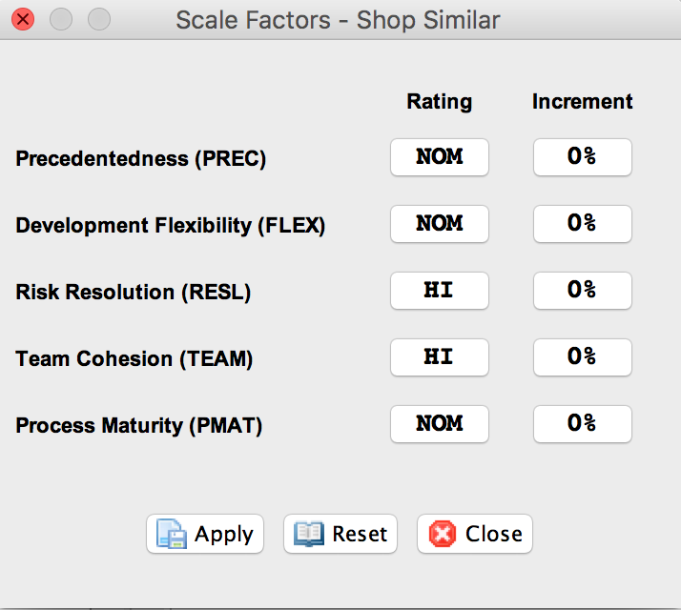

**Figure 1: Scale Factor**

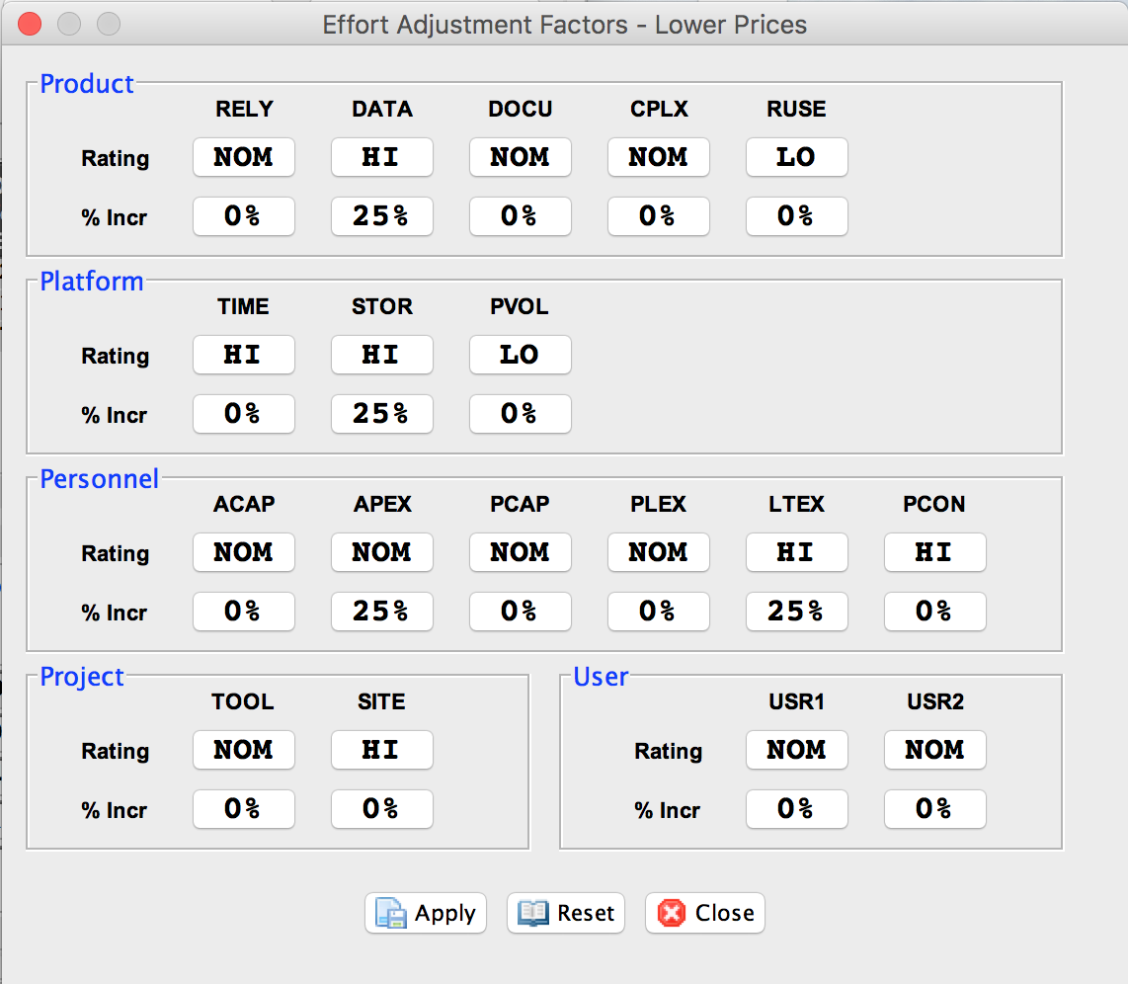

**Figure 2: EAF-Lower Price**

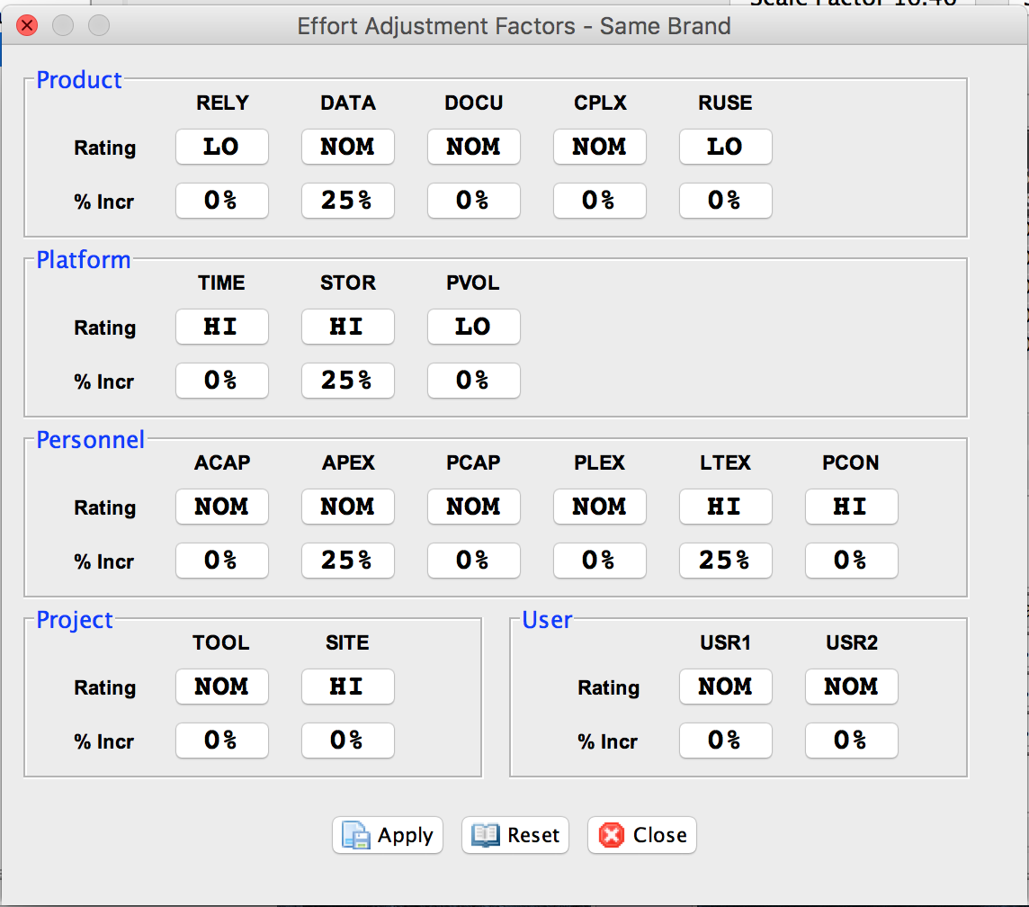

**Figure 3: EAF-Same Brands**

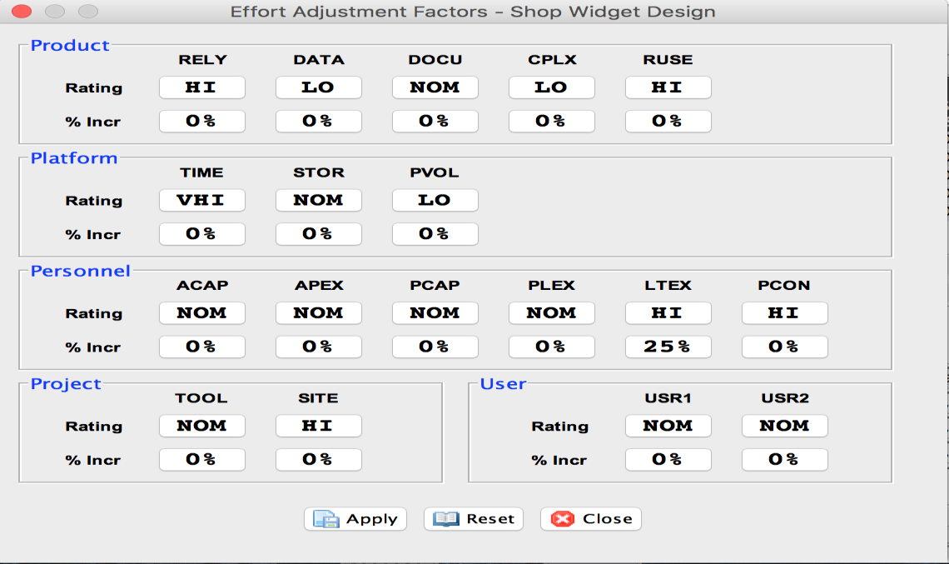

**Figure 4: EAF-Shop Widget Design**

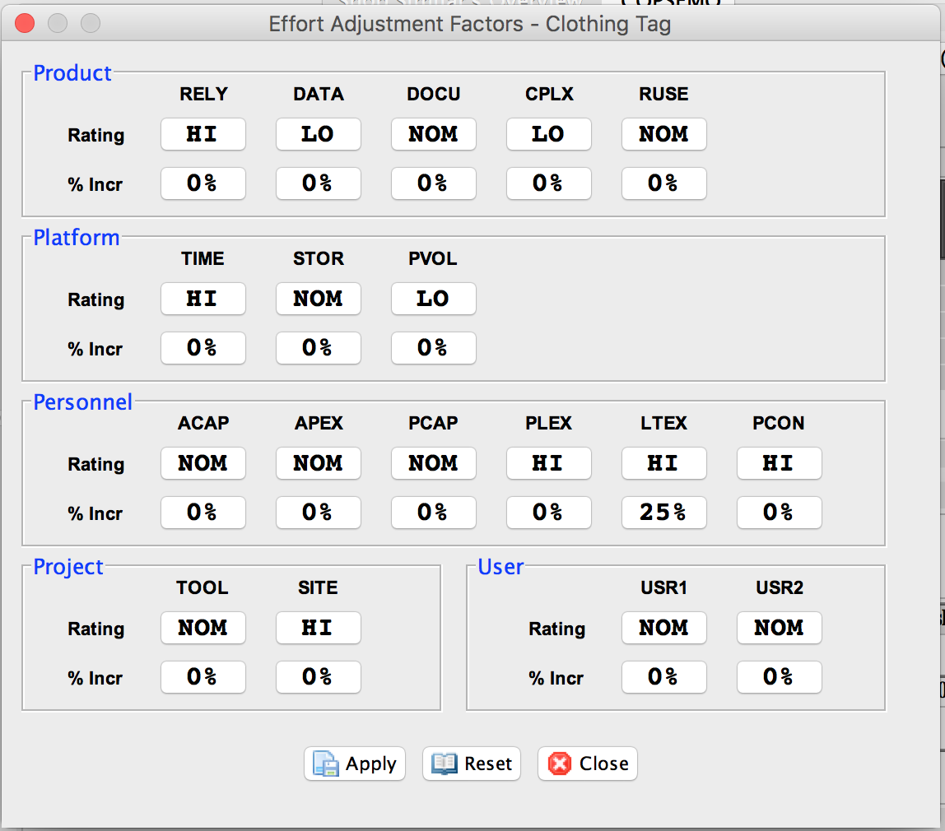

**Figure 5: EAF-Clothing Tag**

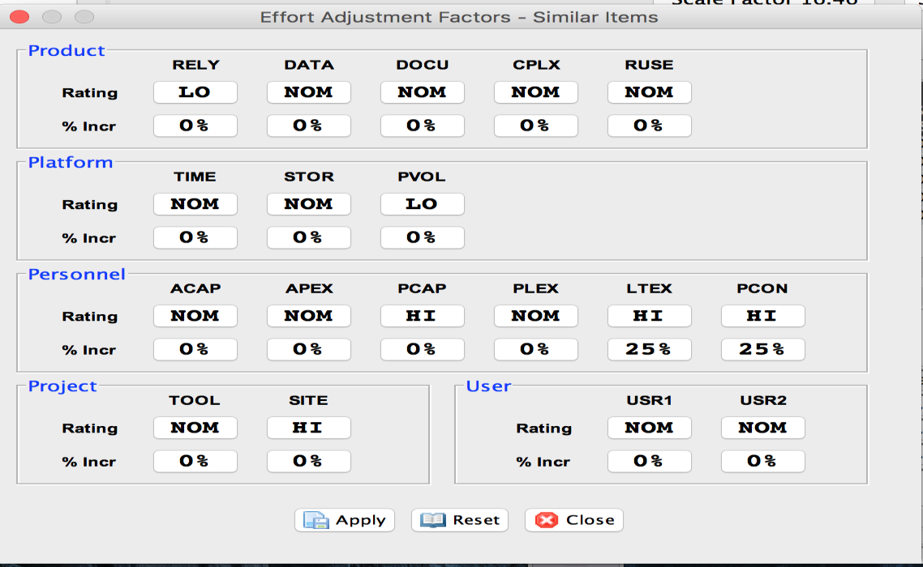

**Figure 6: EAF-Similar Items**

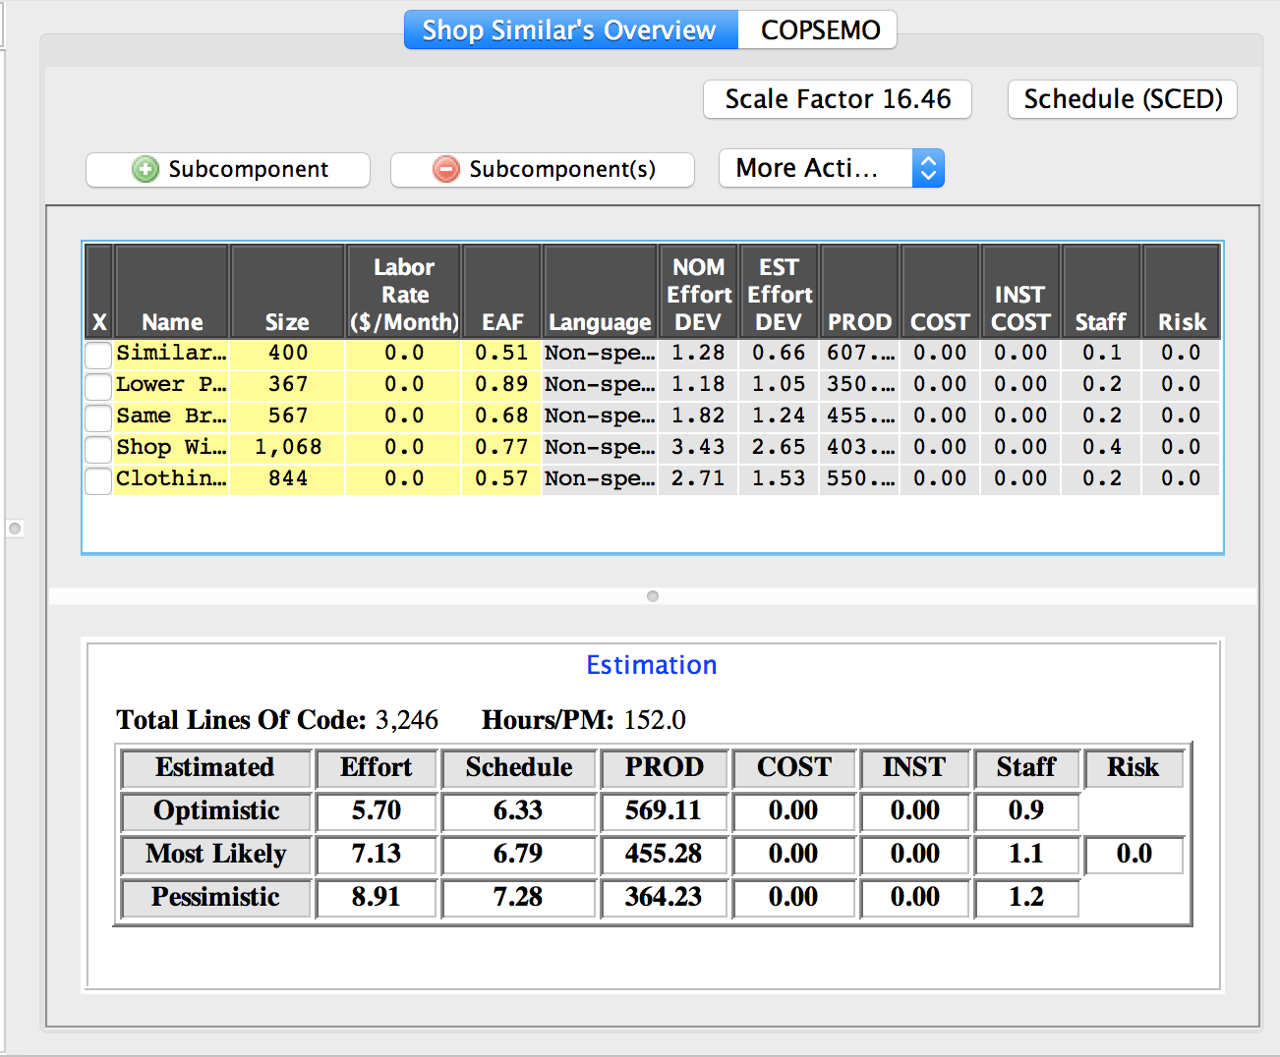

**Figure 7: CoinComo Estimate Results**

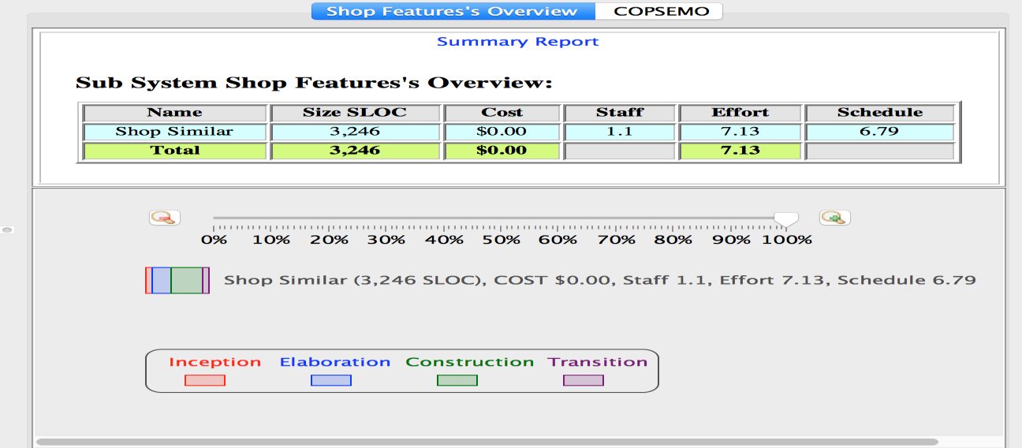

**Figure 8: CoinComo Summary**

The conclusion from the COINCOMO estimation is that the effort and schedule values specified above was a reasonably accurate estimate of hours and effort needed to deliver the required modules of our project as we could finish the modules within the desired timeframe

Iteration Plan

**6.1 Plan**

The construction iteration of the Development phase consists of the following user stories:

**6.1.1 Construction Iteration: Capabilities to be Developed & Tested**

**Table 9: Construction iteration capabilities to be implemented & tested**

|  |  |  |  |
| --- | --- | --- | --- |
| **To Be Developed** | **Developer** | **Tester** | **Priority**  **Level** |
| **OC-1 Sort Items:** User can sort products based on prices, new  arrival, most popular | Ankur  Palav | Alan  Kwan | Must  Have |
| **OC-2 Shop Widget:** User can view the product in a slide view  fashion and overall better UI | Ashwin  Hariharan | Alan  Kwan | Must  Have |
| **OC-3 Shop similar:** User can search similar items based on  price, color, category and brand | Ankur,  Rishabh | Alan  Kwan | Must  Have |
| **OC-4 Clothing Tag:** User can get the product details on  mouse hover in shop widget | Ashwin  Hariharan | Alan  Kwan | Must  Have |